

We introduced ourselves as Professional Training Institute known as PTi . Earlier, we are the only institute in Eastern India who was providing Chip and Component level educational training as well as servicing. PTi has its own huge ESD TRC Lab equipped with latest Imported Machines and Tools.

Our objective is to be build quality into operations, to ensure zero defect services and thereby achieve excellence in organizational performance.

Every year thousands of Desktops, PCs, Servers, Printers, Monitor and Laptops etc are being sold and these Electronics products becomes faulty/defective during warranty as well as after warranty, we are here to serve the best quality solution under one roof.

We are specialized in repair of Desktop and Laptop Motherboard and have major strategic tie up with Motherboard manufactures/ Importers / Dealers of several companies of peripherals and components.

Our senior engineers are specially trained by these manufactures up to level 4 (L4) standards and critically tested on performance. Our TRC Engineers are completely updated with ESD norms and its precautions so that they can take care of the spares given for repair by our customers/clients. PTi is powered by a group of competent and dedicated professionals with-in-depth knowledge and experience in their respective areas of specializations.

Continuously our RND team is in action to provide the finest repairs for our customers with an immense focus on QUALITY. They are on their toes to get the latest updates on the new coming technologies and update our engineers on all locations.

**STARTED IN 2003 WITH TRAINING SECTOR**

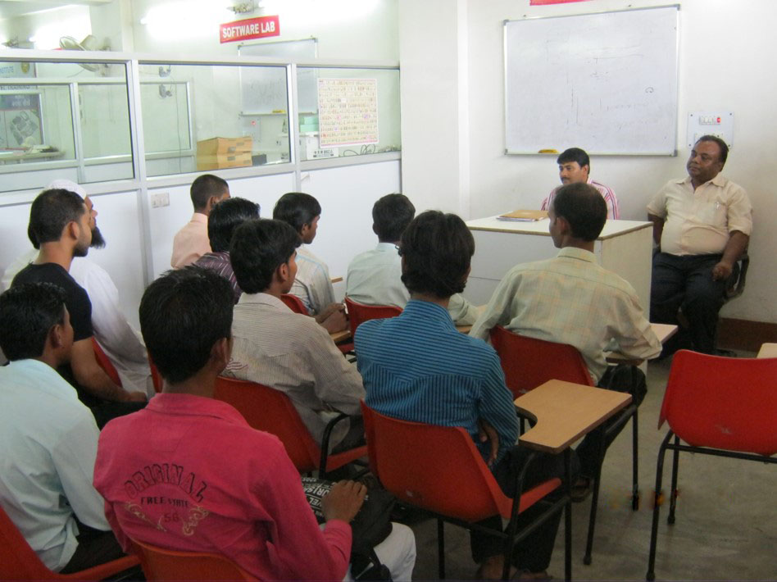 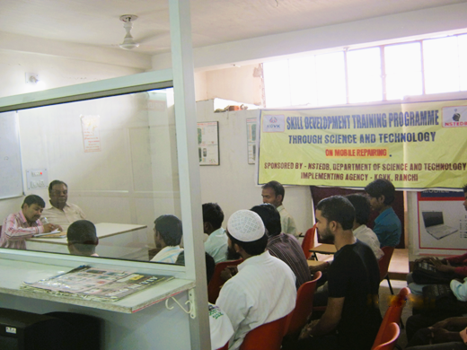

**OUR MISSION & VISION**

Our aim to be one of the best IT Service providers in the industry by ensuring them that we have a team with their positive attitude, committed and skilled to deliver the services you want.



**CONVERTED IN SERVICE SECTOR IN 2008**

**COMPUTER REPAIR** 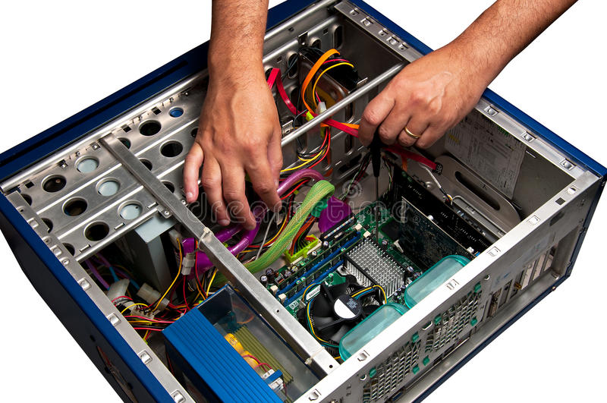

**LAPTOP REPAIR** 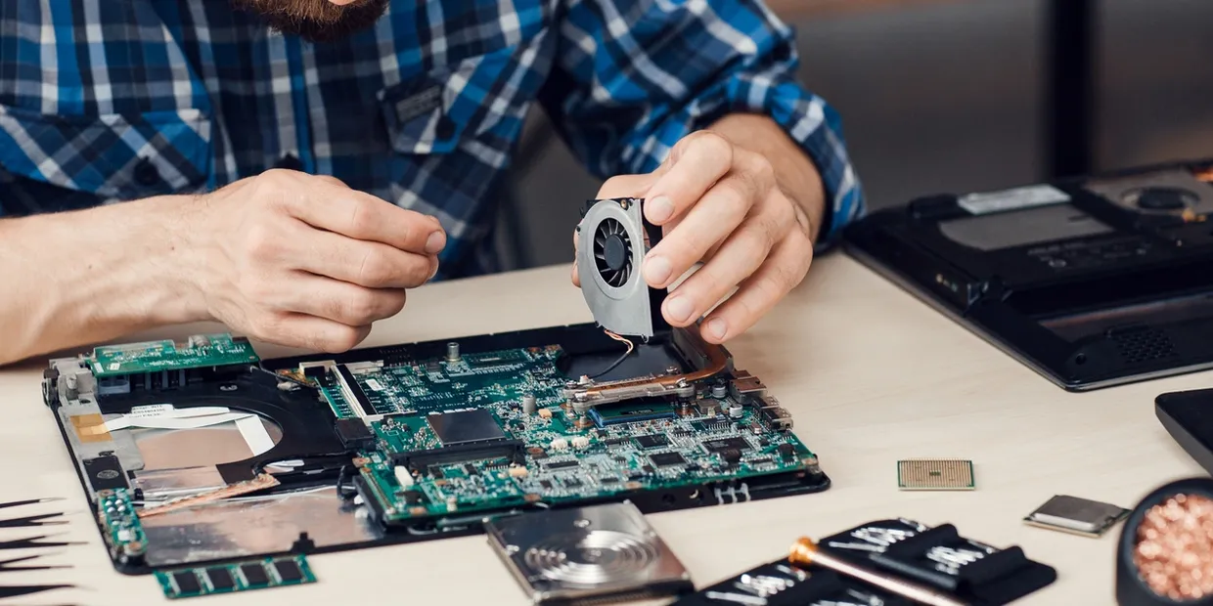

**MACBOOK REPAIR** 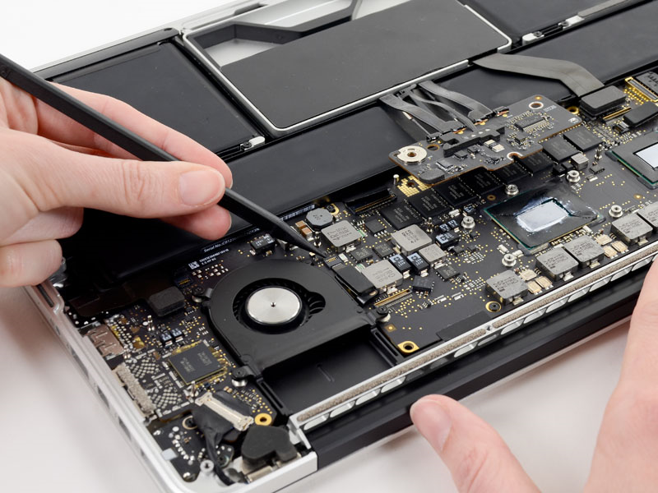

**MONITOR REPAIR** 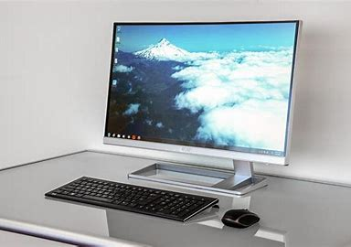

**OUR PRODUCTS AND SERVICES**

**WE SELL**

* NEW AND REFUB PC AND MONITORS.
* COMPUTER ACCESSORIES.
* LAPTOP ACCESSORIES.
* PRINTER PARTS.
* SERVER ACCESSORIES.
* TYPES OF POWER SUPPLY.

**OUR SERVICES**

* AMC.
* ON CALL MAINTENANCE.
* ONSITE SERVICES.
* UPGRADATIONS.

**MACHINES AND TOOLS**

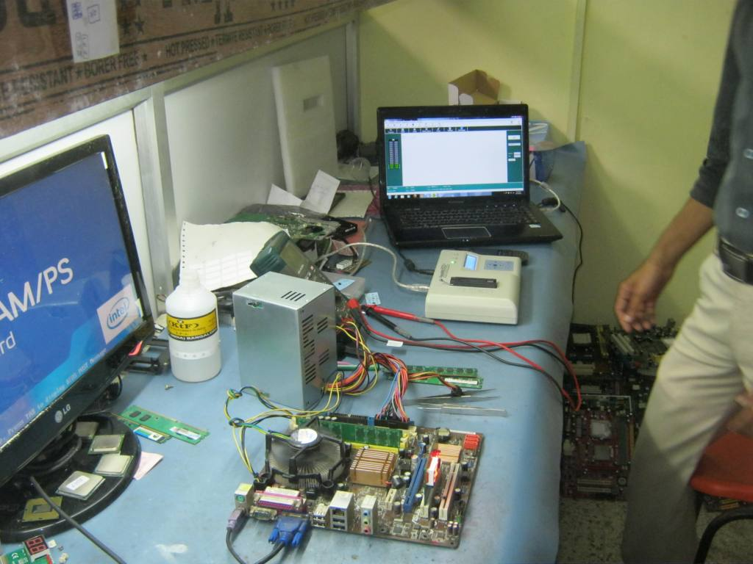 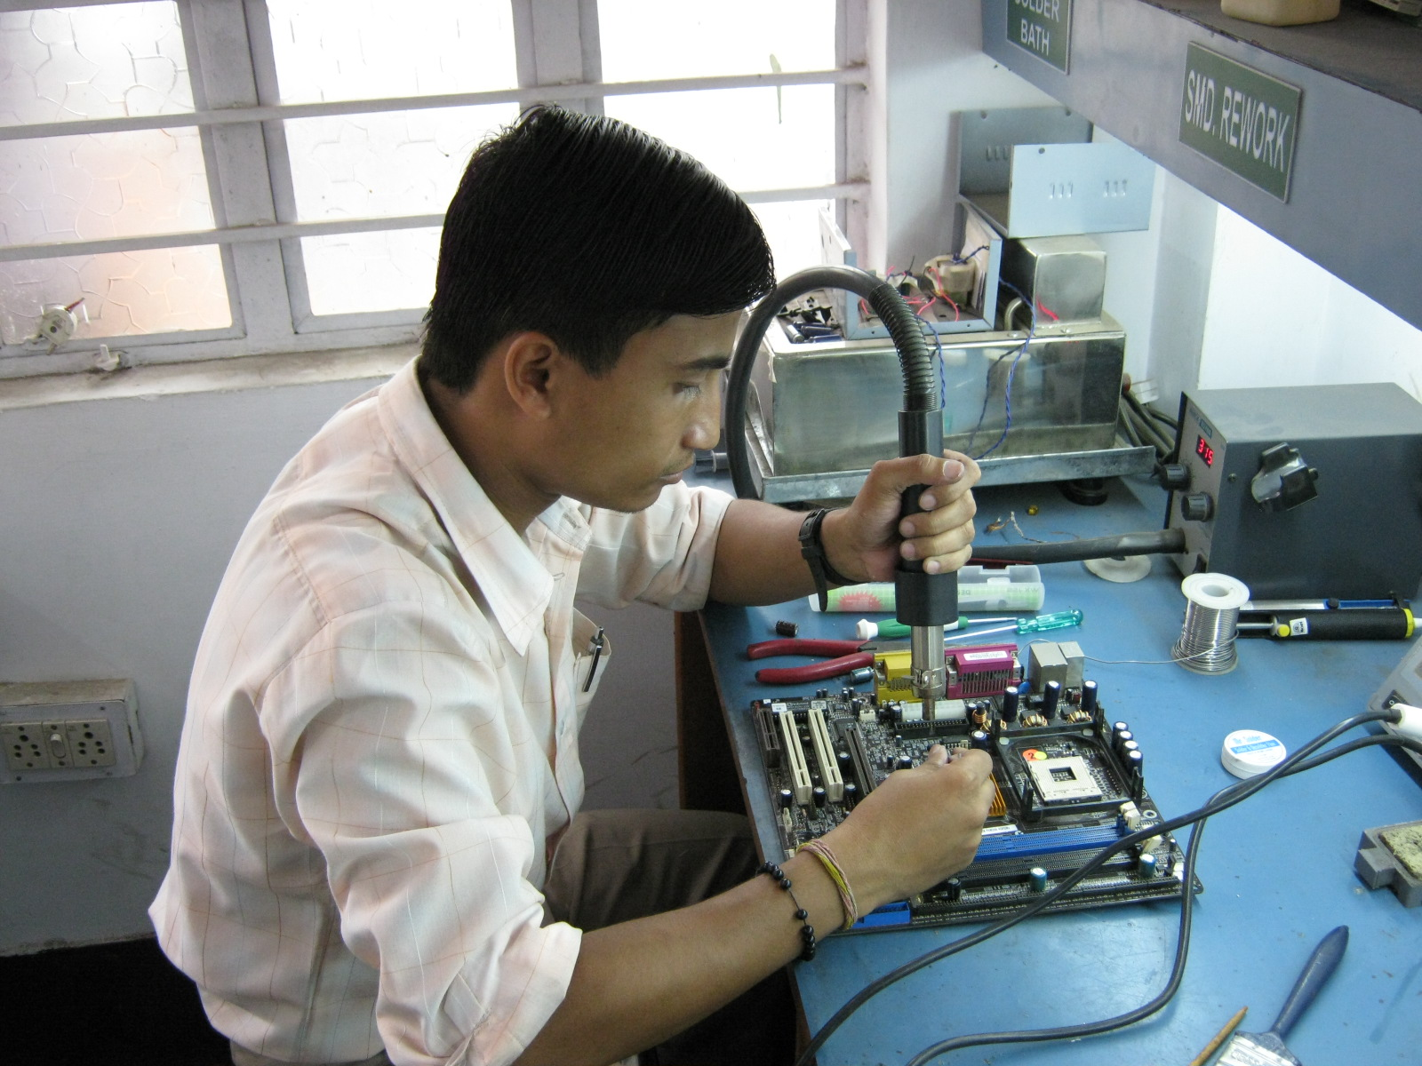

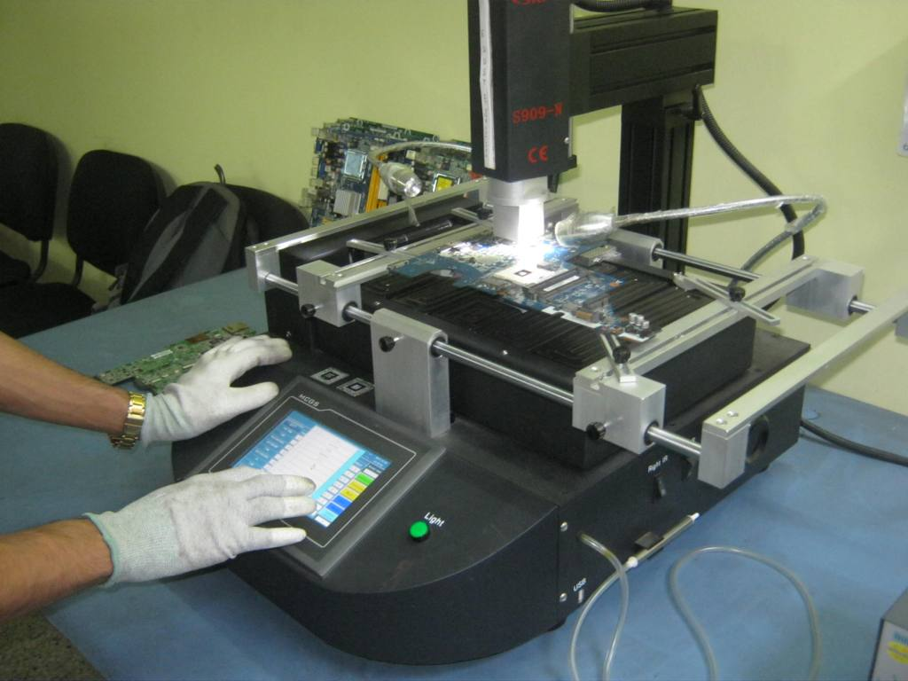 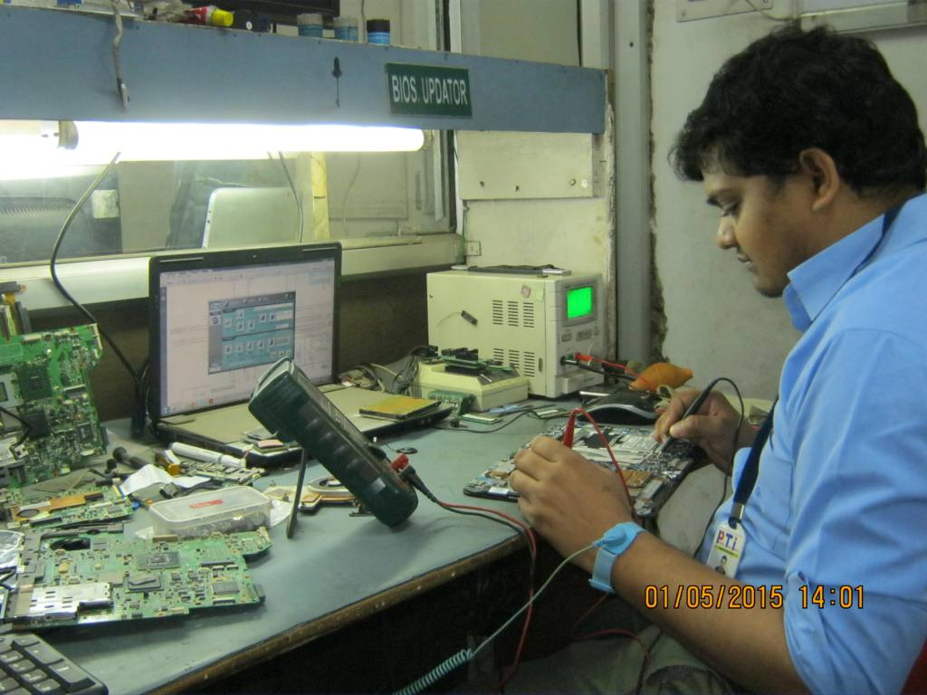

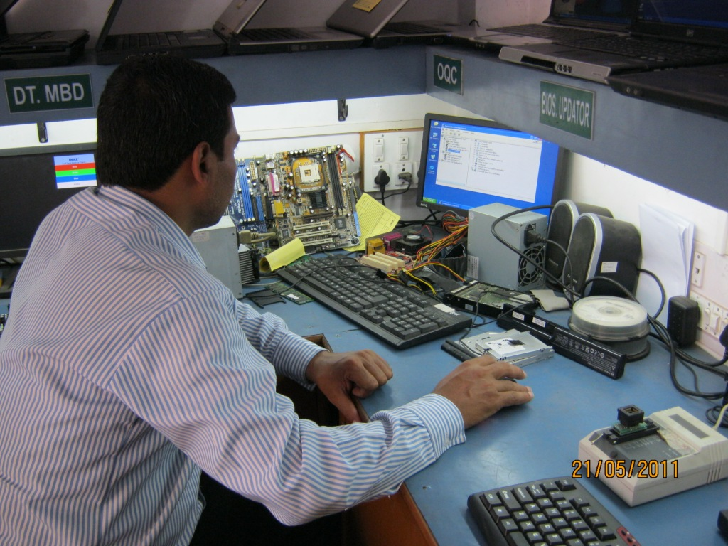 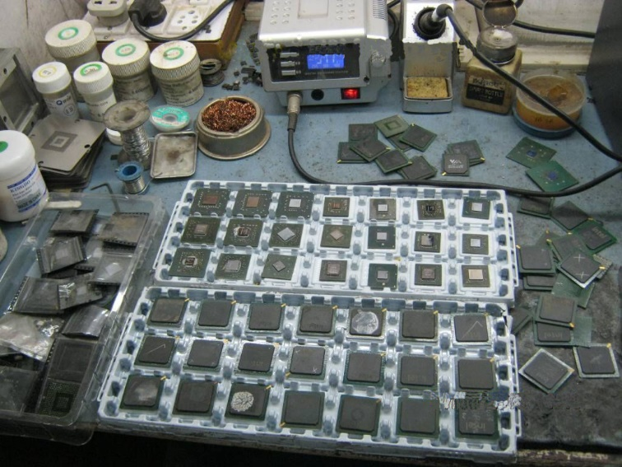

**REPAIR IN LOW PRICES, WITH BEST QUALITY SERVICES.**

 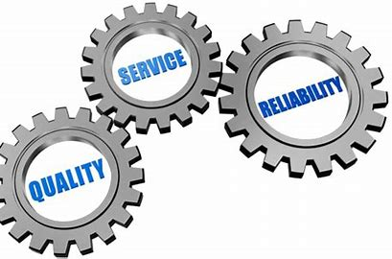

**WARRANTY AFTER REPAIR.**



**OUR MAJOR CLIENTS.**

 

  

 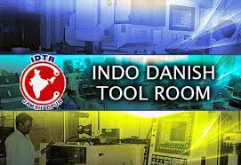

 

**FEEDBACK AND REVIEW OF CUSTOMERS FROM GOOGLE**



**LOCATION IN SAKCHI**

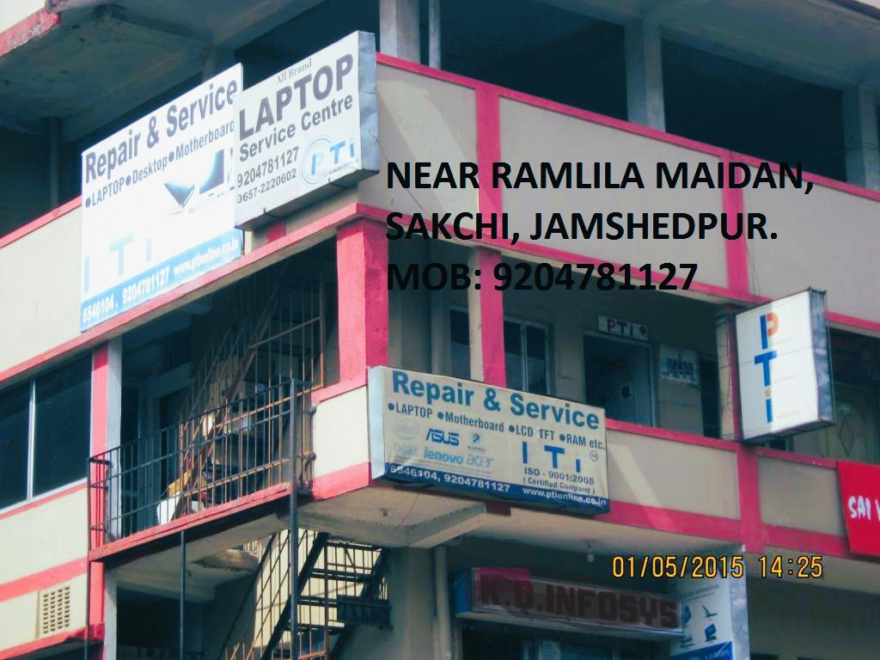

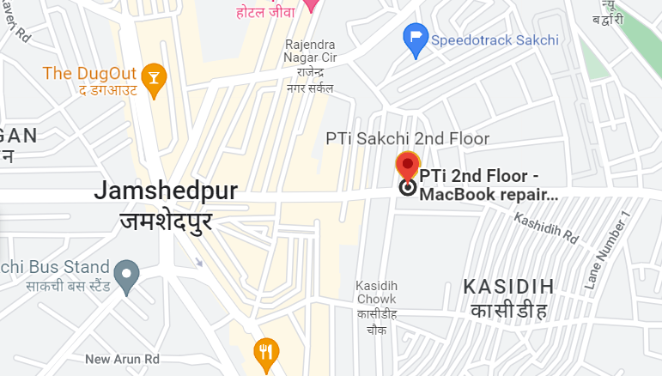

**CONTACT US**

SERVICE CENTER ADDRESS:

H.NO-902, 2ND FLOOR, ST.MILE ROAD, NEAR RAMLILA MAIDAAN, SAKCHI, JAMSHEDPUR. PIN-831001. Email- [ptijsr123@gmail.com](mailto:ptijsr123@gmail.com)

PHONE : 0657-2220602, MOBILE: 7762804272

REG. OFFICE ADDRESS:

H.NO-945, GROUND FLOOR, MOHMADDAN LINE NO-5, NEAR HOLIDEI INN HOTEL, SAKCHI, JAMSHEDPUR. PIN-831001.

Email: [ptiheadoffice@gmail.com](mailto:ptiheadoffice@gmail.com) MOBILE: 9204781127

**THANKS FOR GIVING US YOUR PRECIOUS TIME.**

